Instructions to deploy KYC contract on local private blockchain network setup (Geth / Ganache)

**Pre-Requisite**: Geth based private blockchain network set-up and Truffle Setup

**Note**: Only few of the contract’s APIs are shown.

# Steps to compile and deploy and verify

# Initialize / create a private chain data for our blockchain

|  |
| --- |
| geth --datadir ./datadir_KYC init ./genesis_KYC.json   |

# Start our network

|  |
| --- |
| geth --datadir ./datadir_KYC/ --networkid 20032020 console   |

# Compile our KYC contract code

|  |
| --- |
| truffle compile   |

# Deploy KYC contract

|  |
| --- |
| truffle migrate --reset --network geth   |

# Verify the contact deployed in Ganache

|  |
| --- |
|  |

# Verify the contact deployed in console / Ganache

|  |
| --- |
| truffle console --network geth   |

# Create some banks for verification

|  |
| --- |
| A screenshot of a cell phone  Description automatically generated  A screenshot of a cell phone  Description automatically generated  A screenshot of a cell phone  Description automatically generated    A screenshot of a cell phone  Description automatically generated  A screenshot of a cell phone  Description automatically generated |

# Do some bank operation by setting the ether base in one geth console.

|  |
| --- |
| truffle console --network geth  kyc.addBank('SBI','SBI1','0x20e97dc833826746c9324b4333c42d2d405d0648')  A screenshot of a cell phone  Description automatically generated  kyc.addBank('ICICI','ICICI1','0x0fee2d900fb28b07bf6f9d38c2f34afd26dafae8')  A screenshot of a cell phone  Description automatically generated  kyc.addBank('DBS','DBS#123','0xb3d12625484c6567cece4d170e52c6095beda315')  A screenshot of a cell phone  Description automatically generated |

# Do some admin operations apart from above Bank creation and verify on Ganache / Truffle

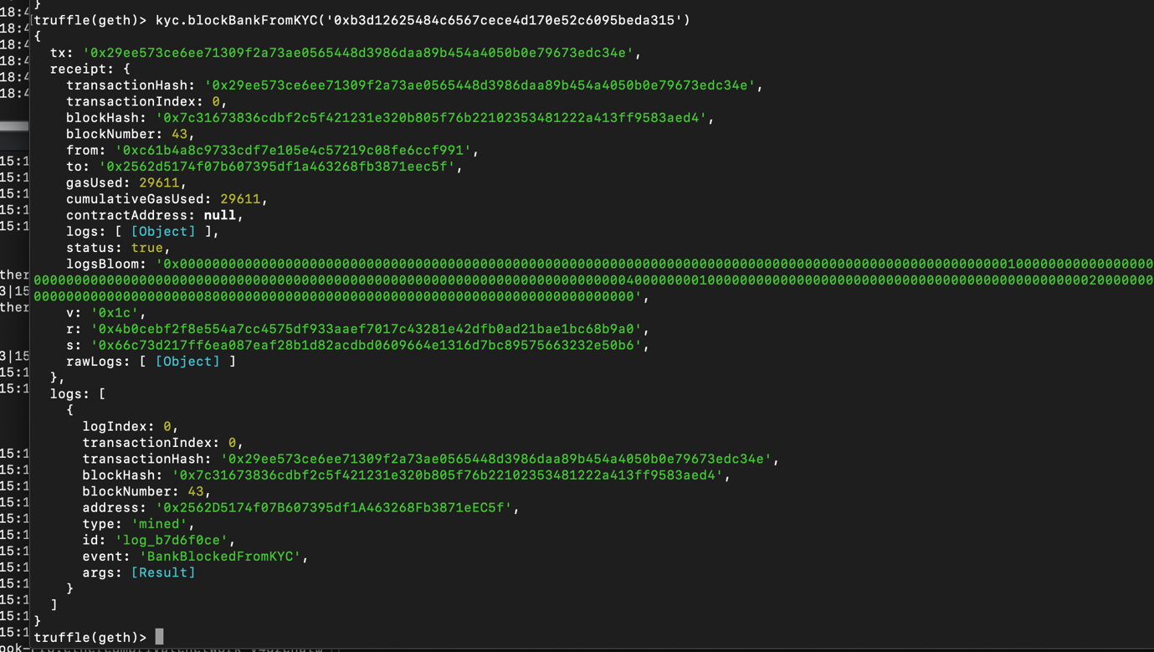

# Do some bank operation by setting the ether base in one geth

# Add KYC Request

|  |
| --- |
| kyc.addNewCustomerRequest('rajesh','GADEPARTHI')   |

# Up Vote Customer

|  |
| --- |
| kyc.upVoteCustomer('rajesh')   |

# View Customer

|  |
| --- |
| kyc.viewCustomerData('rajesh')   |

# Report Bank

|  |
| --- |
| kyc.reportSuspectedBank('0x20e97dc833826746c9324b4333c42d2d405d0648')   |